Create VPC with 2 private and 2 public subnets.
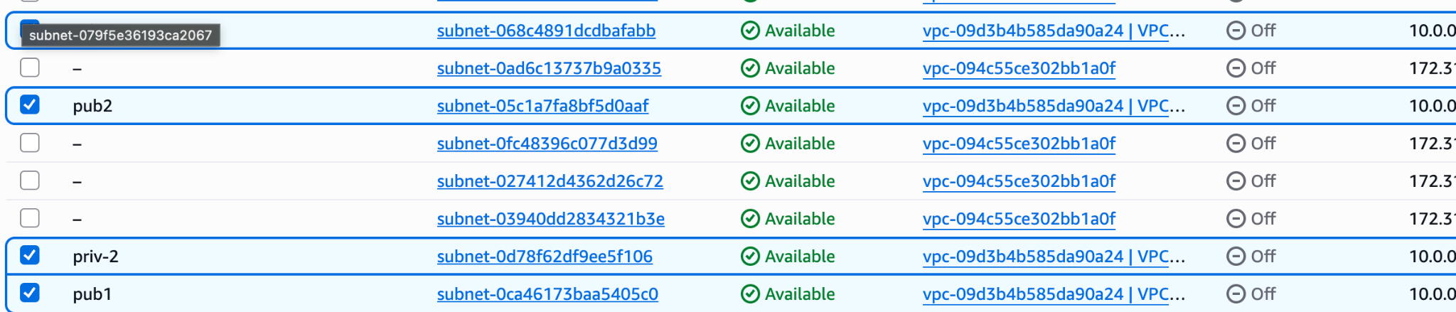
Enable DNS Hostname in VPC.
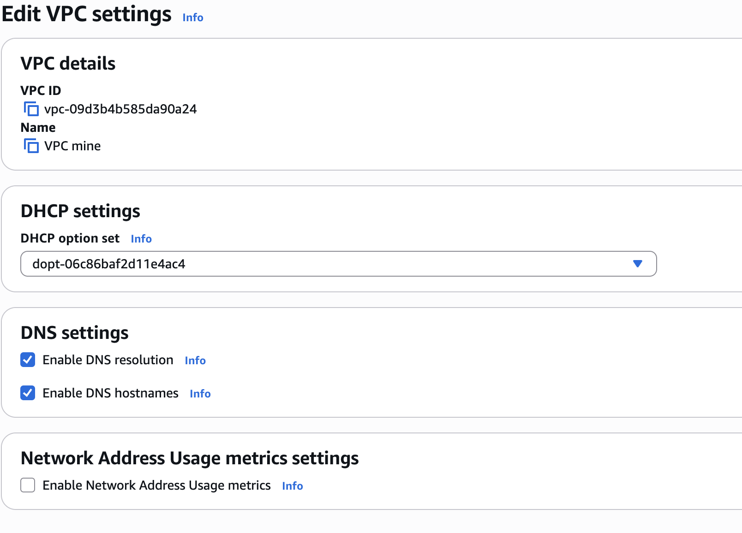
Enable Auto Assign Public IP in 2 public subnets.
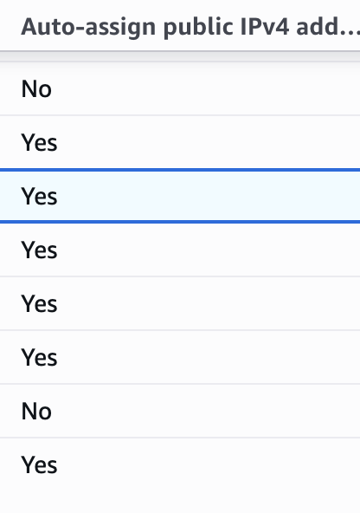
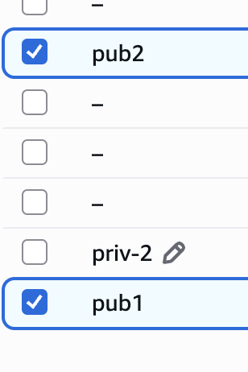
Add 2 private subnets in the private route table.
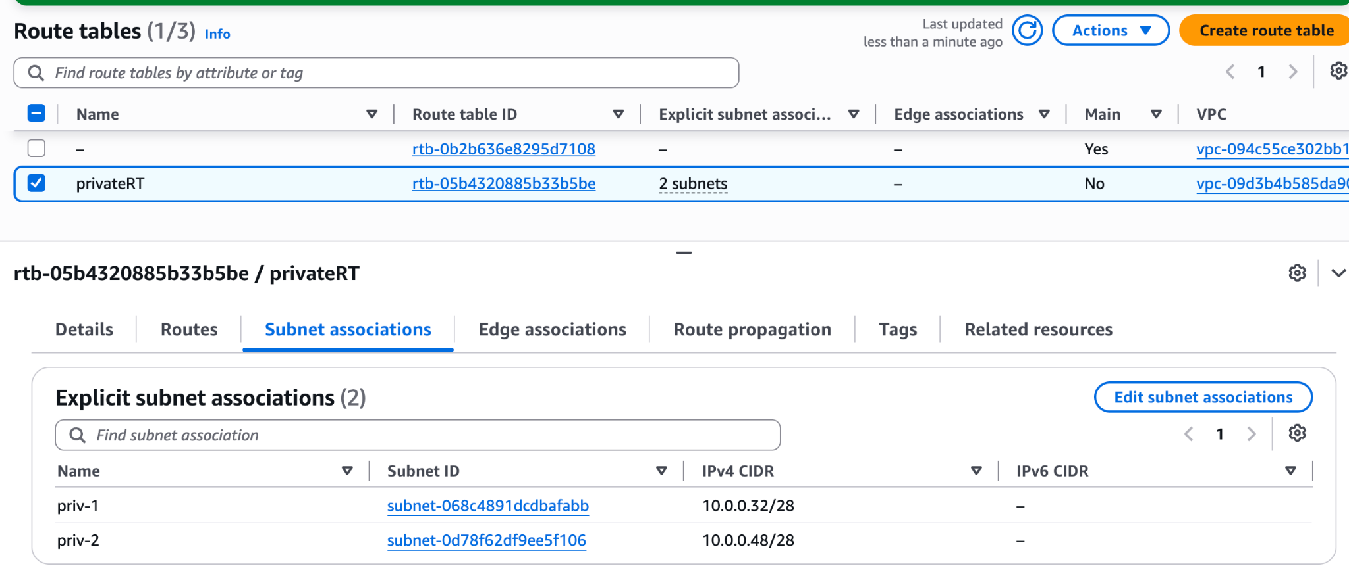
Add 2 public subnets in public route table.
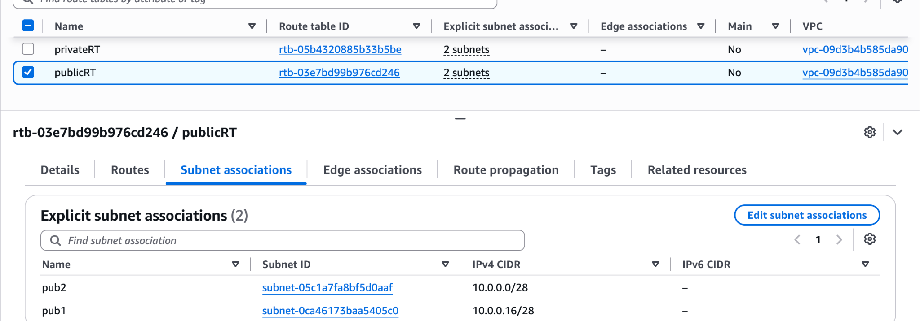
The public route table will have the routes to the internet and local.
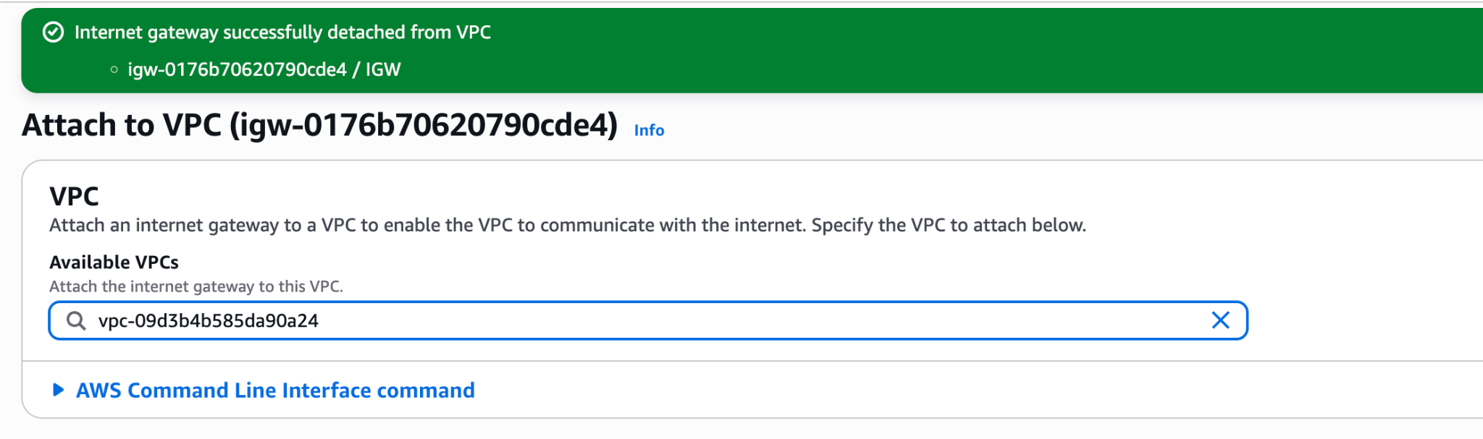

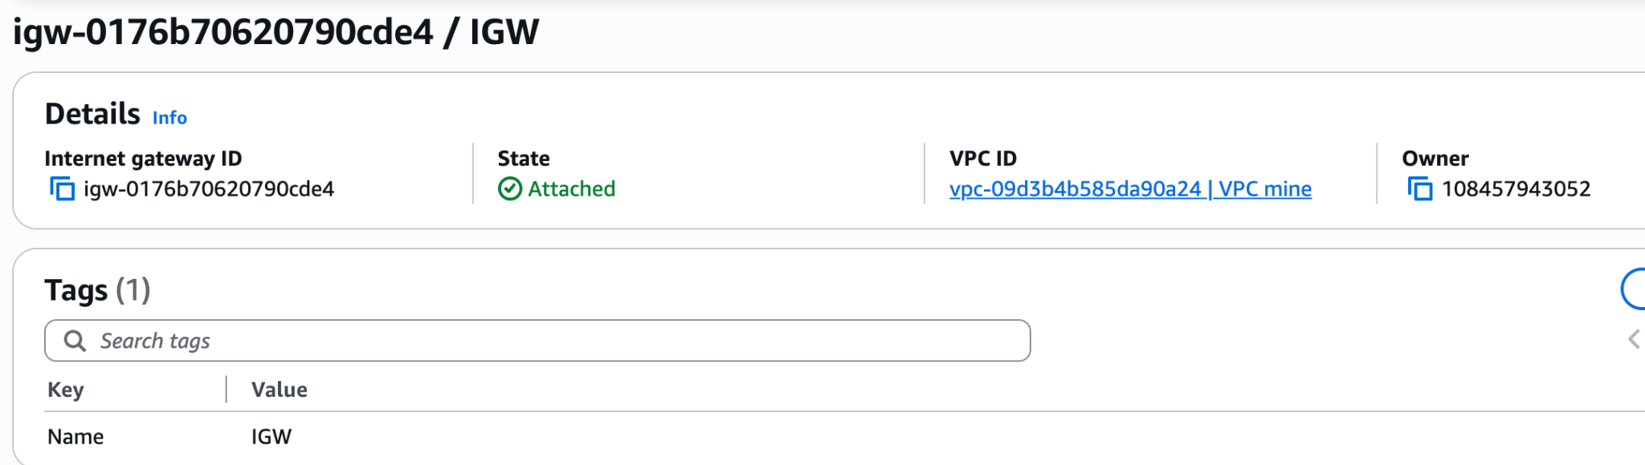
Create EC2 in a public subnet with t2.micro and install PHP.
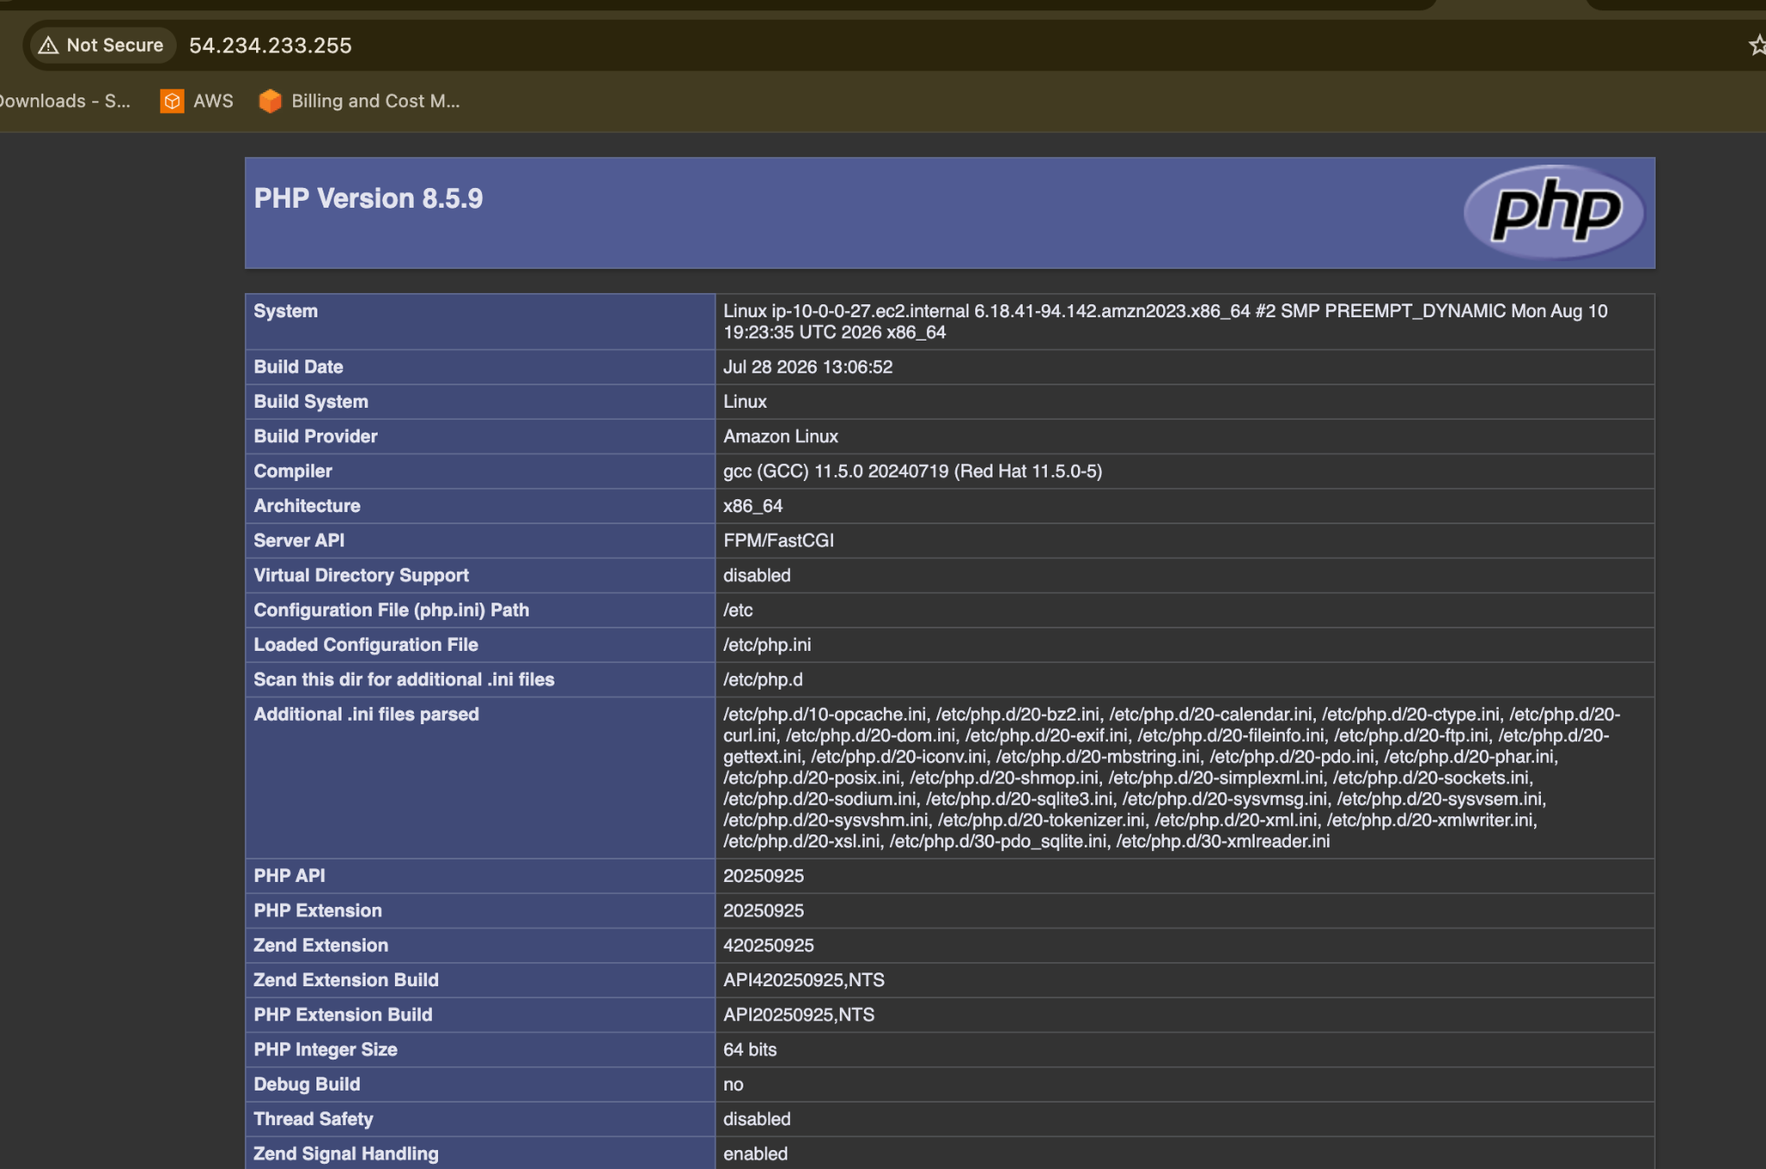
Connect to the EC2 and install PHP.

For Amazon Linux 2023:

sudo dnf update -y
sudo dnf install httpd php -y

Start Apache:

sudo systemctl enable --now httpd

Check:

systemctl status httpd

Create PHP test:

echo "<?php phpinfo(); ?>" | sudo tee /var/www/html/index.php

Configure NAT gateway in public subnet and connect to private instance.
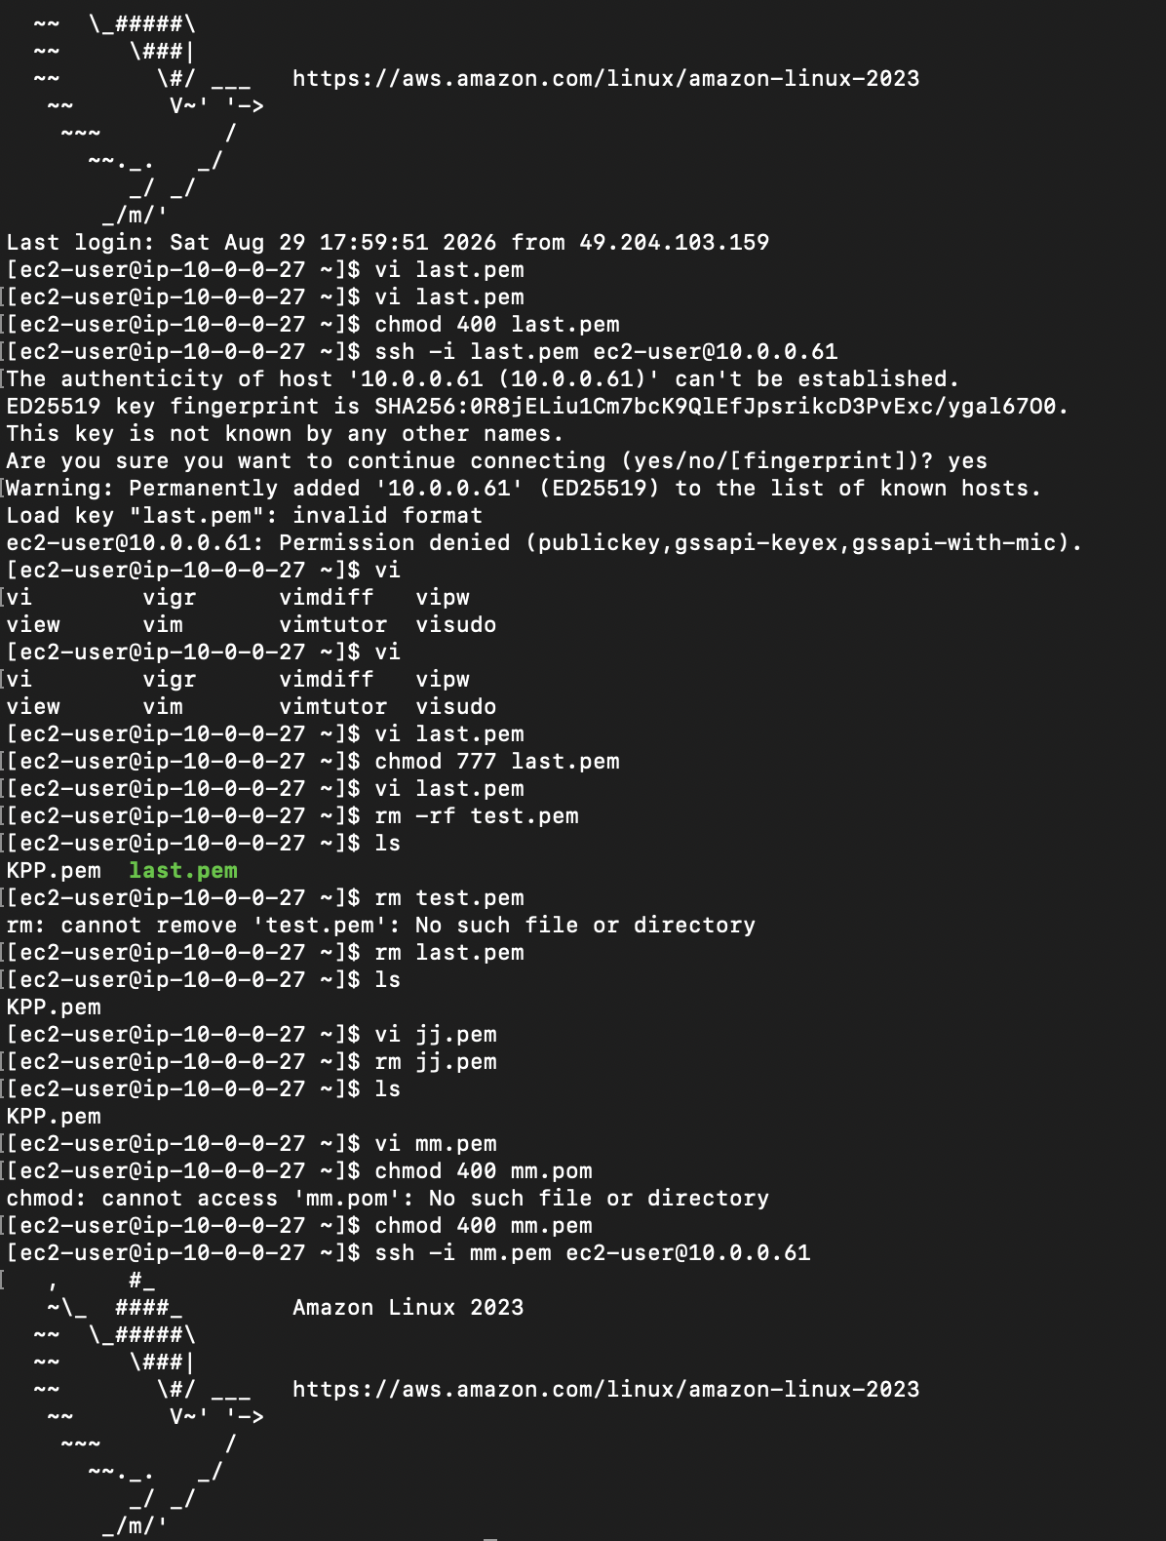
Install Apache Tomcat in private EC2 and deploy a sample app.
